

Management Reports Guide

Introduction

*Revised 06/11/2018*

**SUNSTATE EQUIPMENT COMPANY**

Management Reports Guide

This guide contains proprietary information of Sunstate Equipment Co. Its information and use is intended solely for the use and reference of Sunstate employees. Such proprietary information may not be used, copied, reproduced, or disclosed to any other parties for any other purpose.

Copyright © 2003-2018 Sunstate Equipment Co. All Rights Reserved.

SECTION 2 – WEEKLY REPORTS

Small Balance Temporary Inactive Report 24

On Truck – Status “K” – By Location 25

New Accounts 26

Reactivated Accounts 27

Status Change to Accounts 28

Customer Credit Limit Exceeded 29

Weekly Credit Memo Summary Report 30

Equipment Service Call – Code 150 31

Lost Rental Log – Weekly 32

Aerial 90 Day Inspection Report 33

SECTION 3 – MONTHLY REPORTS

Equipment Utilization Report 34

Contract Trends Report 35

Regional Analysis Report (RP Report) 36

Equipment Revenue Report 37

Equipment Utilization History – By Month 38

Equipment Exchange List 39

Equipment Service Call Report 40

No Activity Report 41

Repairs as a Percentage of Revenue 42

Equipment Not Serviced in 90 Days 43

Sales Summary by SIC Code – By Volume 44

Sales by Customer Report 45

Suspended Customers 46

New Accounts – No Activity Report 47

Equipment Transfers – Sending/Receiving 48

Introduction

SECTION 1 – DAILY REPORTS

Daily Invoice Reconciliation 1

Large Equipment Utilization Trends 2

Small Equipment Utilization Trends 3

Contract Trends 4

Inside Shop Status 5

Equipment in Outside Shop Status 6

Washrack Status “R” 7

Daily Cash Sales Journal 8

Open Pick Up Tickets 9

Daily Overridden Rates or Amounts 10

Overridden Rates or Amounts Back-Dated 11

Open/Closed Contract Detail 12

Blank Page 13

Open P.O. Report 14

Open Contracts with Re-rent Equipment 15

Delivery & Pickup Charges Overrides 16

Equipment Exchanged List 17

Reservation Listing 18

Credit Memo Summary – Daily 19

Pick-up Rollover Report 20

Lost Rental Log – Daily 21

Auction Equipment Not Delivered 22

Equipment Inventory Balance Report 23

Table of Contents

This guide is an overview of the standard management reports for daily, weekly and monthly, the daily ones need to be viewed through your Cognos Dashboard each morning. The weekly and monthly automatically print at the branch. The sample report examples and information illustrate how to read and use the reports as an effective tool in managing the business.

It gives direction on how to identify trends with fleet, business activity and overall branch operations. Many of these reports should be crossed referenced to gain a complete and clear perspective.

Remember, these reports are historical data that should be used only as a tool which should never replace daily involvement with the operations.

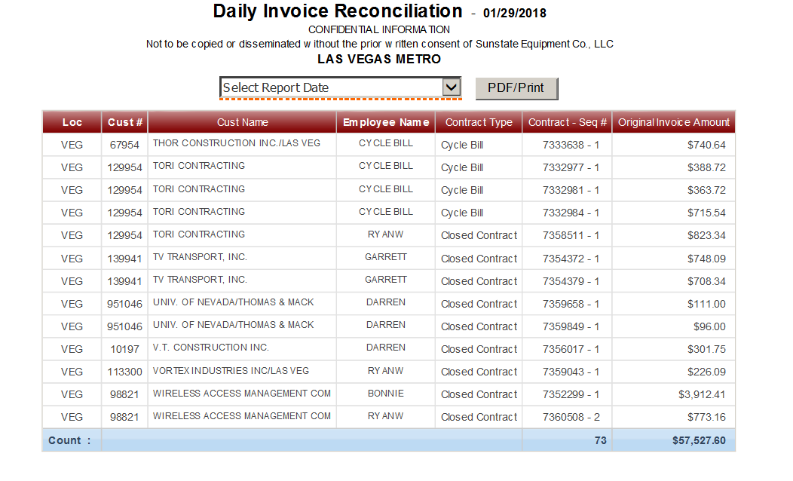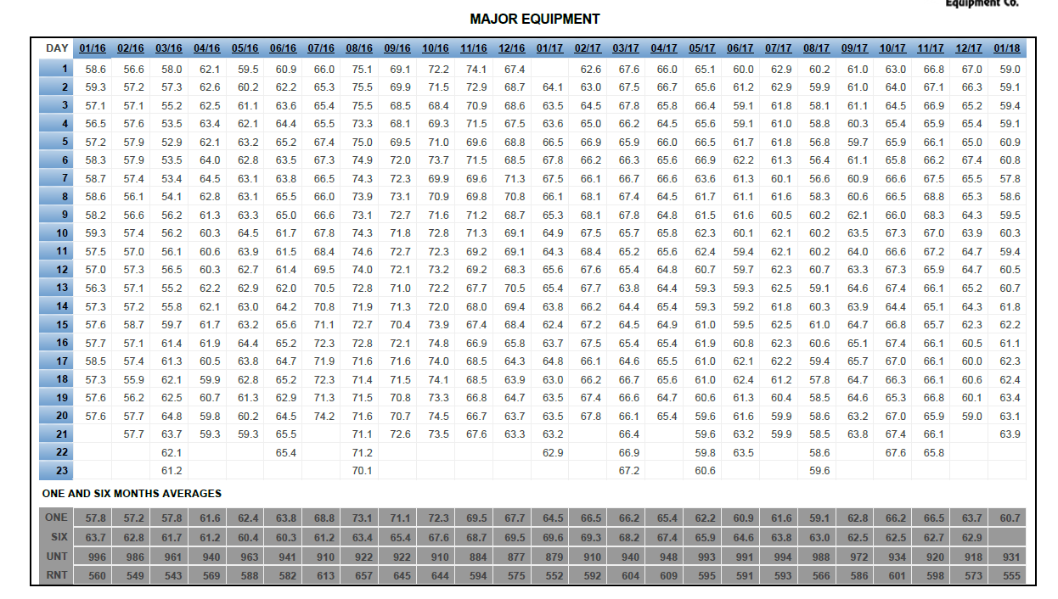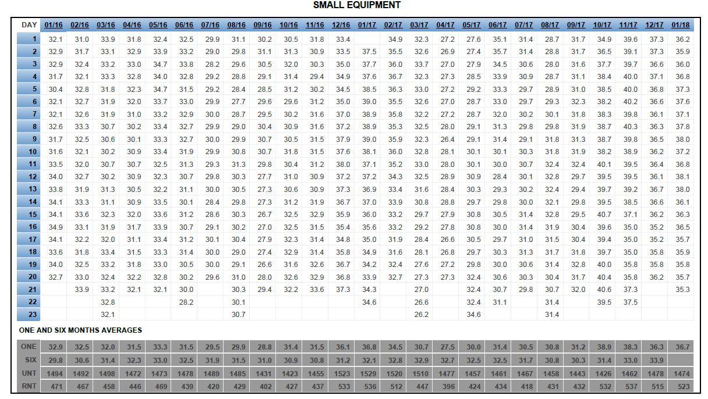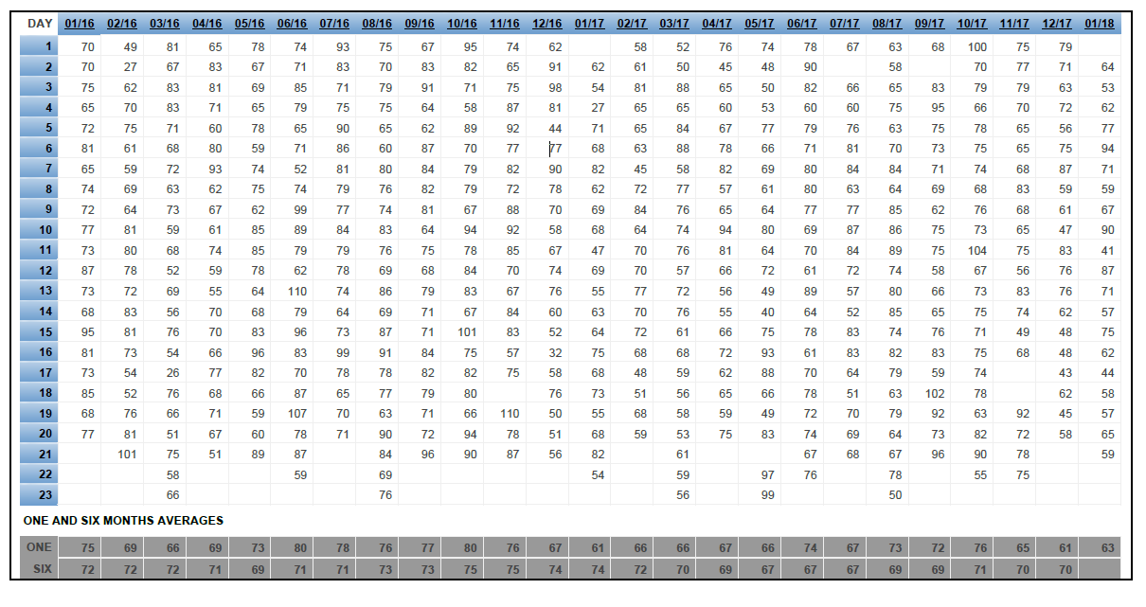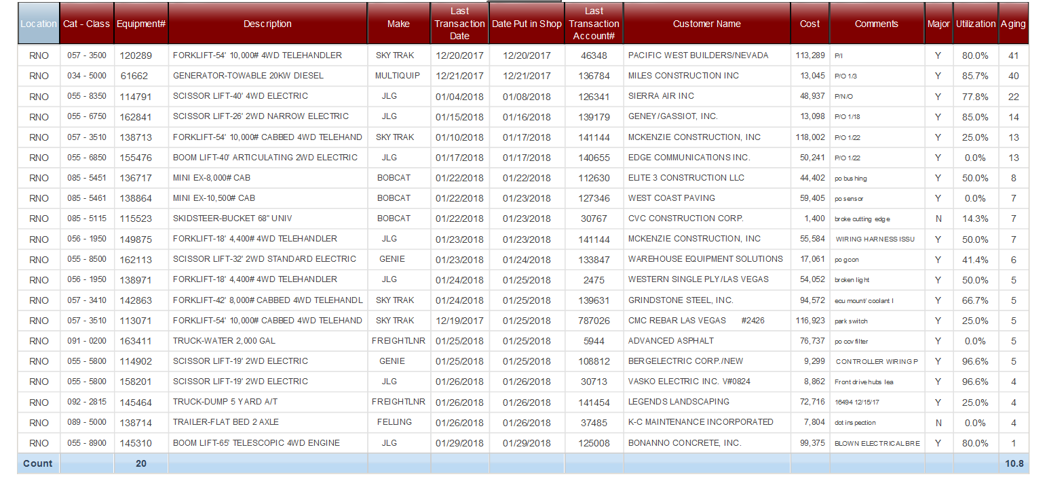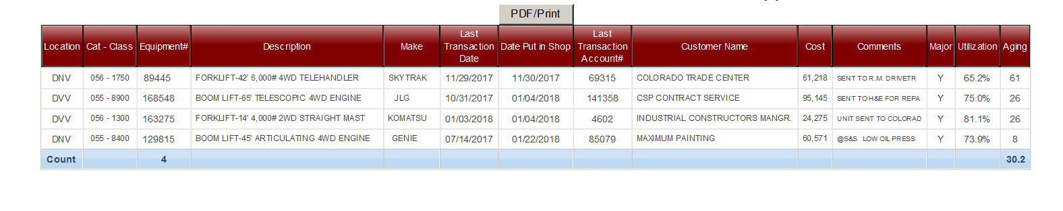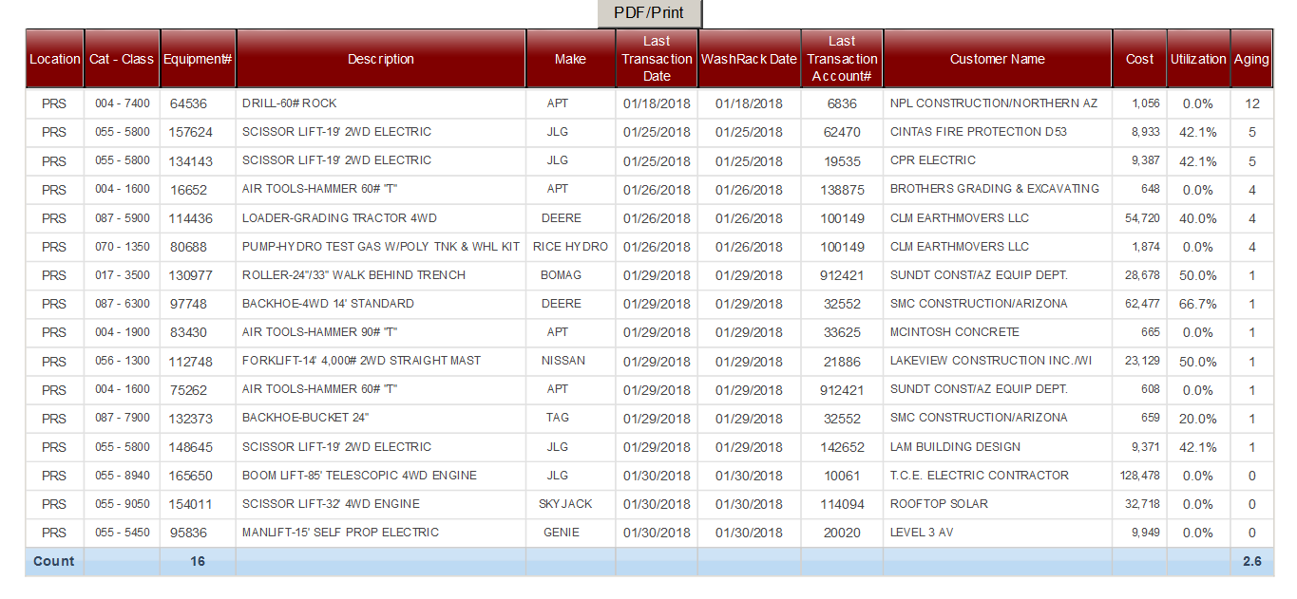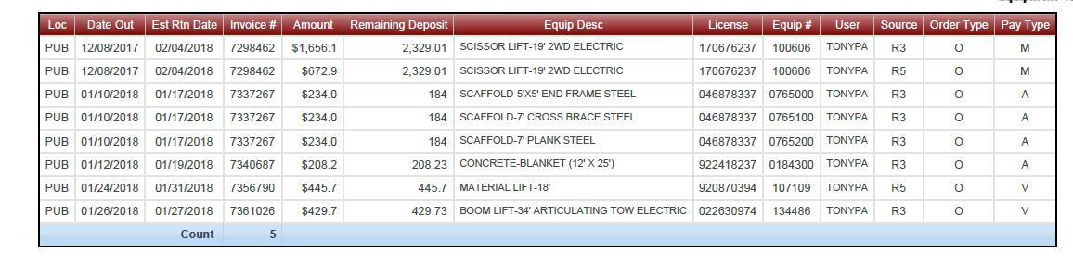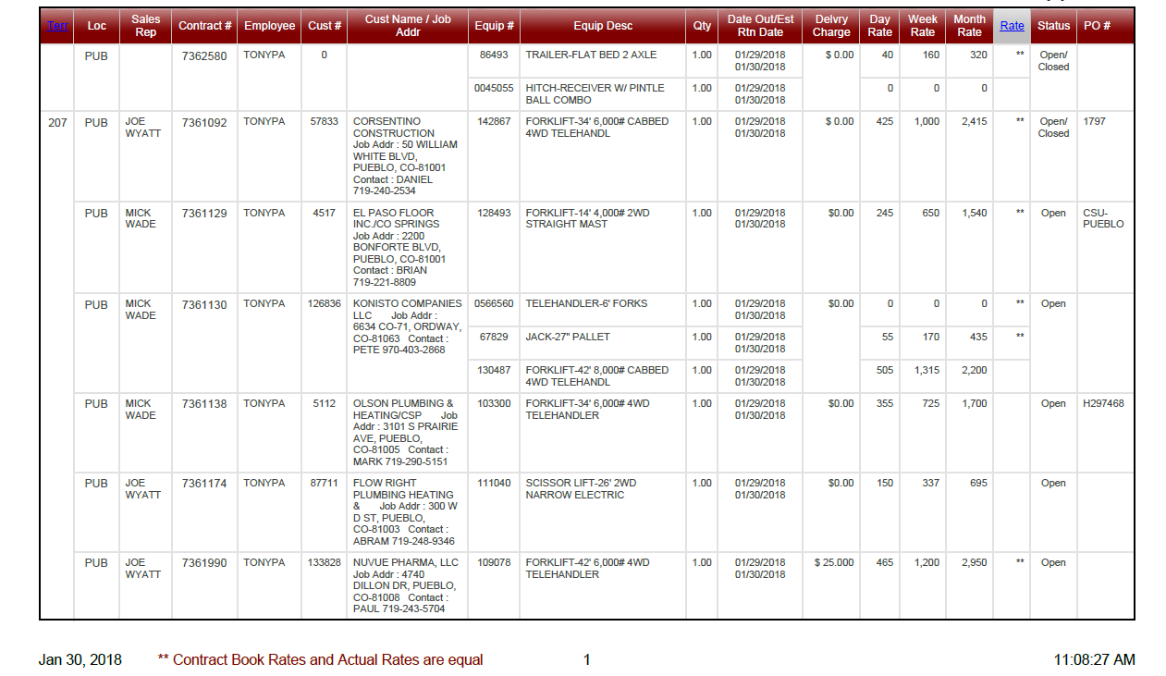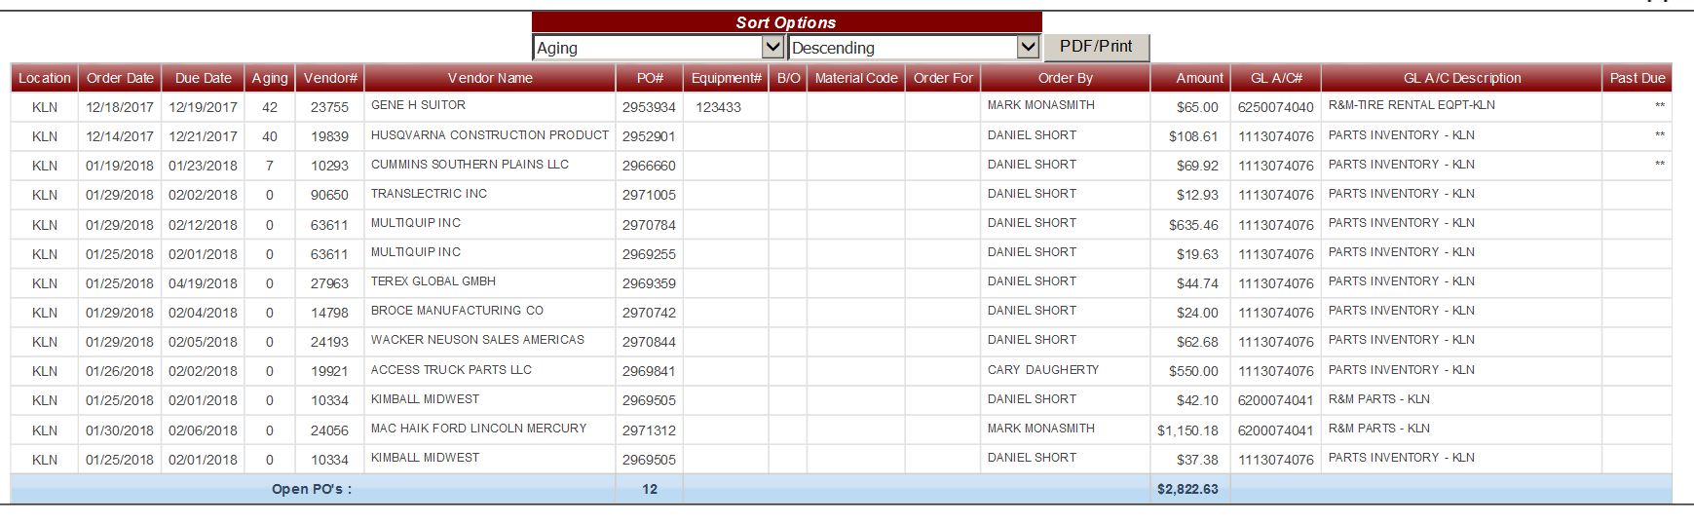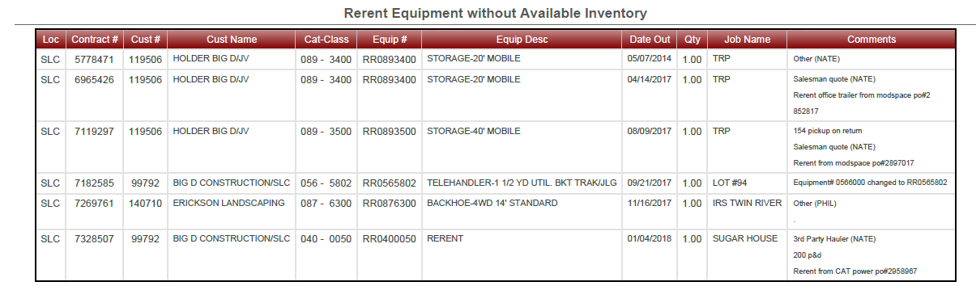

**MANAGEMENT REPORTS GUIDE**

Daily Reports

You can select the date you need if other than current the date

**Guidance -Throughout:**

* Review all “on account” closed contracts from the previous day.
* Reconcile daily invoice & Ensure all invoices are accounted for and physically review each invoice to ensure that they were processed accurately.

## Daily Invoice Reconciliation Report

**The invoice totals should match the number of invoices in hand as well as the total dollar amount of the invoices.**

These list out in alphabetical order for faster reconciliation

Shows you who closed the invoice.

1

**Compare current utilization to past 12 and 24 months utilization trends**

**A good target for large equipment is between 60% and 70%**

## Equipment Utilization Trends for Major Equipment

* The bottom of each half of the report lists:
  + One month’s utilization average (ONE)
  + Six month’s utilization average (SIX)
  + Number of units in the fleet for the month (UNT)
  + The total number of units on rent (RNT)
* Review trends compared through the past 25 months.
  + General overview of fleet activity
* Use monthly average as a bench mark, compare it against last years monthly average and the previous month
  + When comparing utilization, pay attention to the number of units in your fleet to help understand trends.

(ie; Is utilization up due to an increase of business, or a decrease in the size of fleet?)

* **Determine the % of the fleet that was on rent for each billable day.**
  + Majors goal = 60% - 70% (equipment cost that is over $5000)
  + Each day utilization percentages are calculated during nightly reporting. Any equipment that shows “on rent” or “scheduled for pick up” will be calculated into the utilization percentage. All returns and rental outs must be processed by the end of the day in order to achieve an accurate percentage.
  + If a rental contract is opened and closed during the same day before the nightly reporting, the piece of equipment will not be reported as being on rent for the day.

2

**A good target for small equipment is between 20% and 30%**

**Compare current utilization to past 12 and 24 months utilization trends**

## Equipment Utilization Trends for Small Equipment

* The bottom of each half of the report lists:
  + One month’s utilization average (ONE)
  + Six month’s utilization average (SIX)
  + Number of units in the fleet for the month (UNT)
  + The total number of units on rent (RNT)
* Review trends compared through the past 25 months.
  + General overview of fleet activity
* Use monthly average as a bench mark, compare it against last years monthly average and the previous month
  + When comparing utilization, pay attention to the number of units in your fleet to help understand trends.

(ie; Is utilization up due to an increase of business, or a decrease in the size of fleet?)

* **Determine the % of the fleet that was on rent for each billable day.**
  + Small Equipment goal = 25% - 30% (equipment cost that is under $5000)
  + Each day utilization percentages are calculated during nightly reporting. Any equipment that shows “on rent” or “scheduled for pick up” will be calculated into the utilization percentage. All returns and rental outs must be processed by the end of the day in order to achieve an accurate percentage.
  + If a rental contract is opened and closed during the same day before the nightly reporting, the piece of equipment will not be reported as being on rent for the day. This is why the small equipment utilization is much less than large equipment utilization.

3

## Contract Trends

* Identify trends in the number of contracts written for each billable day of the month.
  + One and six month averages are listed at the bottom of report
* Measure the level of activity.
  + Is the daily business growing or fading?
  + Compare to previous months and season to determine what action needs to take place to meet current and future business levels

(ie; hiring, adding delivery / rental fleet, etc.)

4

* Another tool to aid in determining staffing needs to meet the level of business.
  + Opportunity to identify if the team is working efficiently with current business level

3

**The “reason in shop” comments should be specific enough so you can manage your downed equipment. Information is put in by the mechanics on his tablet in the work order on the top (Concern Line). For example: Bad Controller this tells you what you need to know.**

**You can monitor the parts tracking on the managers work order screen in the AS400**

**This shows you the average number of down day’s total**

**This is utilization % for that cat class of equipment, if it is running at 70% or above or it has a reservation against, then it would get moved to the top of the list on the mechanic’s tablet. We need to make it a priority. The goal is a 4 hour turnaround time frame.**

**“The Plane is leaving”**

* Compare “Date Put In Shop” to “Last Trans Date” to identify if there is an issue with the time to diagnose, yard flow issue or if unit was on ready line when the problem was caught by a driver or yard person
* Communicate urgency of getting equipment turned around by setting priorities
* Equipment that has been inside shop for longer than 48 hours

**This shows you the aging days it has been inside shop**

5

## Inside Shop Status

* Track and monitor broken pieces of equipment in the fleet daily
  + Review “Date Put In Shop” to identify if we are meeting our 48 hour turnaround goal
  + Understand the “Reason In Shop” to identify if customer damage, routine maintenance issues or warranty
  + Determine if parts have been ordered
  + What units are running 70% utilization (Priority)

**When the mechanic changes the work order to outside repair he should update the Concern line so we can see where the unit is going to and what type of repair it is.**

**(Sample) RDO/ Rear End issue**

## Equipment in Outside Shop Status

**As soon as the unit is put in the load zone to be sent to the outside repair facility your mechanic should be immediately changing the work order to outside repairs for proper tracking and follow up on repair status.**

* Track and monitor equipment that is sent out to an outside repair facility
  + Follow-up on the progress daily
* Follow-up and communicate a sense of urgency with the vendor to ensure that the equipment is repaired in an acceptable time frame to minimize the chance of losing rentals.
* Always get a completion date from the vendor so you can hold them accountable to that.
* Communicate with your Regional Service Manager and or District Service Manager prior to sending equipment to outside shop for repairs so that all options can be discussed beforehand.

6

**This is utilization % for that cat class of equipment, if it is running at 70% or above or it has a reservation against, then it would get moved to the top of the list on the mechanic’s tablet. We need to make it a priority. The goal is a 4 hour turnaround time frame.**

**“The Plane is leaving”**

* Should be covered with lead shop person each morning.
* The ‘**last transaction date’** represents the day the invoice was closed. This report should be used to set priorities in the shop along with the mechanic’s tablet and the Inside Shop Report too. (The expectation is that equipment is serviced and made available within 24 – 48 hours.)

### Equipment Wash Rack (Status “R”)

**This shows you the average number of days on the washrack**

7

**Make sure we are getting the correct deposit amount.**

**The rental charge for the length of the rental plus the deposit amount**

**All cash contracts should not exceed one week rental unless approved by the Branch Manager**

* Review the previous day’s closed “cash” contracts daily
* Ensure that all cash invoices have been accounted for and documented on the “Payment Checklist”
  + Compare to the actual invoices in hand
  + Verify payments have been received for each contract

**Compare the payment type listed to the form of payment attached to the contract to ensure accuracy.**

8

**Determine if customer’s driver’s license number was used to enter their personal information. A copy of their driver’s license should also be attached to the invoice.**

## Daily Cash Contracts

* Ensure that all equipment that is scheduled for pick up is being picked up within 24 hours.
  + Follow up with dispatch and compare this report to the “Dynamic Dispatch Screen” to ensure accuracy of the report and dispatch are the same.
  + A unit might have been posted in the dispatch screen by mistake and it will show up on the report but not in the dispatch screen anymore

**Using the F-10 comments in the AS400 when taking something off rent will help in communicating any billing information that might be needed before closing the ticket out.**

**It can also save additional questions and/or confusion.**

* Ensure equipment that is on a long term rental is being maintained
  + Review the “Last Maintenance Date” to determine if a full service is due
* Call the customer to get a current hour meter update and from there you can determine if the unit is overdue for an oil change.
* If the customer can’t help us then send an outside sales person or
* If it’s due for a full service, schedule an exchange at the customer’s convenience. We prefer to perform the service in our shop because we can easily perform a more thorough service on the unit and/or perform any repairs.
* If an exchange can’t be done then schedule your service mechanic to go out and perform the service in the field

**The pickup date and time the unit was scheduled off rent by the inside sales person.**

**This is utilization % for that cat class of equipment and aging time off rent. Be sure dispatch is reviewing this daily.**

* Our goal is to have the equipment picked up the same day if it is called off rent before 2:00 PM.

**“The Plane is leaving”**

**You can quickly see if something was secure or not when it was called off rent. If it was not secure than why didn’t we pick it up the same day it was called off rent?**

* Use the report to prioritize the pickup of low inventory equipment so that all reservations can be fulfilled.
* Use inside Sales phone log to compare ensure everything scheduled and we didn’t miss any entries.

9

8

## Open Pick Up Tickets

**We should always have Comment on why we have overridden the rates**

**These codes represent the reason that the rental rate was overridden in the AS400.**

* Review any rate adjustments on any closed contracts from the previous day.
* Review the comments underneath the customer’s company name to:
  + Determine if adjustment was justified
  + Identify if there are any selling issues.
  + Are we adjusting the rates due to customer objections?

## Daily Overridden Rates or Amounts

10

**Putting in F-10 notes about something special in the billing on the contract is a big help to who every is closing the contract**

**This would be the Back- Dated time & date that this employee entered into the system, overriding the default time & date**

**This is the system time & date it was entered into the computer**

11

## Overridden Rates or Amounts

## Back-Dated

* Backing up the time & date could in some cases just be because a customer called a unit off rent and asked if we would stop the rental a few hours earlier.
* It is common to have an outside sales person call into the office asking to have a unit taking off of rent as of a few hours earlier or even at 5 pm the night before, as they may have just left a job site.

**The Double Asterisk represents Book Rate for the item rented. This should be reviewed daily by Outside Sales to help eliminate any credits due to wrong rates.**

**We should always try to obtain an exact address when an order is placed.**

**A P.O. number was not received when this order was taken. It is important to follow up with the counter person so they can update the contract with a P.O. number before it is closed. Many customers will not pay an invoice if it does not have their P.O. number on it.**

12

## Open Contract Detail

* Review business / customer activity from the previous day.
* Use it to identify:
  + Which customers are renting and the type of equipment they are renting
  + Any discounted rates
  + Did we charge delivery and pick up on the open contract
  + Did we add additional rental rates to extra buckets and augers
* Review for detail on contracts.
  + Sufficient job addresses (for pre-lien information)
  + Customer’s P.O.’s entered (if required)
  + Accurate territory numbers
* After reviewing give to the outside sales team so they also have awareness of customer activity.
  + Sales can use as a follow up tool to thank the customer for a rental

13

## Blank Page

**Note:**

* OSR P.O.’s
  + With Tires are we still waiting for a bill from the vendor? It shouldn’t take any longer than 24 hours to receive the bill so we can quickly re-bill the customer if necessary
  + Oil Changes in OSR trucks & Manager’s trucks, we should have all the info when the oil change is completed.

**The (**) means the shipment is past due.**

**Review prices listed for each P.O. to ensure that the purchaser is receiving the price at the time of order.**

**We should never see P.O.s for $1.00**

**Regional Manager approval is required for all purchases over $1,000.00 if not for equipment**

14

**This P.O. was issued 42 days ago, so the flag here is the “due date” which was a few days after when the order was placed.**

**We should be managing our parts orders by the due dates so we can hold our vendors accountable. Work with you parts manager on orders that are past due so they can follow up on it.**

### Open P.O. Report

* Compare it to the open P.O. file to determine if report is current.
  + **Verify that all open P.O.’s have been G/L coded correctly**
  + It can identify orders that were cancelled with the vendor, but not cancelled in the AS400
  + It can identify P.O.’s that were not received when the merchandise was physically received at the branch

13

14

**This rental contracts needs to be updated with the proper comments in the “equipment detail screen”.**

**Our guidelines are we do not re-rent to or from our competitors. We prefer to rent from dealerships or from non-direct competitors.**

**Review the type of equipment re-rented to determine if we can exchange it with our own equipment.**

**Review the customers who we re-rented for.**

16

## Open Contracts with Rerent Equipment

* Review re-rent activity to identify if proper re-rent guidelines are exercised (Branch Manager should be involved with the entire process)
  + Customers that we rented for are credit worthy and loyal to us
  + Similar equipment to our fleet
  + Where we rented from
  + Could we have substituted another piece of equipment?
* Comments should list:
  + Sunstate P.O. to the vendor
  + Who the vendor is
  + What the equipment is if “misc.” was used because we don’t have a category / class number for it.
* Determine if an exchange is scheduled so we can exchange it with our equipment when available.
* Follow up to ensure that it was logged as a “Lost Rental” using the “Re-rented unit from vendor” code.
* Share list with outside sales team so they have awareness when they visit the job site.

**This is showing you charges we Did Not collect because of the free delivery and pickup comment reasons.**

**This is the reason why we over road the charges**

**This helps keep the branch managers informed as to why we didn’t charge for delivery or pickup.**

**This indicates what type it was**

16

## Free Delivery & Pickup Charges Overrides

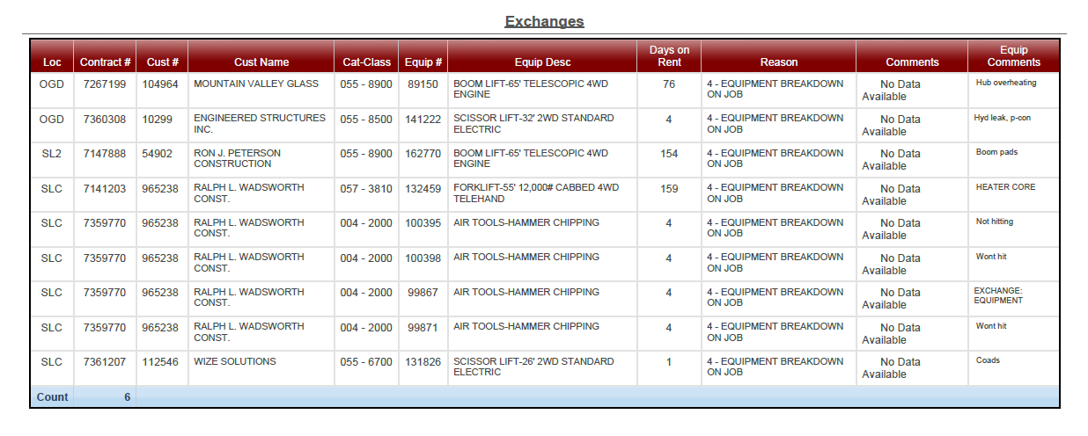

**An example of the unit being exchanged the same day it went out causing inconvenience for the customer and us.**

**Review the listed customers to determine if any of them are repeated which may identify possible misuse.**

17

18

* Review exchange comments to identify what caused the exchange:
  + Was it customer misuse?
  + Was it a shop servicing issue?
  + Did the driver load the wrong unit?
  + Did the counter ask enough questions to qualify the equipment’s application?
* Share with the shop and counter daily for awareness and to possibly prevent future exchanges.
* Look at day on rent to identify potential customer service issues.
  + Did we exchange the unit the same day it was delivered causing inconvenience and frustration for the customer?
  + This also causes operational inefficiencies.

## Equipment Exchanged List

**The past due reservations should be researched to verify if the orders were cancelled, changed or overlooked.**

**If they were cancelled, the reservation should be deleted in order to keep the report current and the availability search screen in the AS400 accurate. Old past due reservation will automatically drop off after 7 days**

18

## Open Reservations Report

* Review future reservations for inventory availability and planning.
  + Multiple units (ie; several light towers, etc.)
  + Limited or scarce inventory items
* Keep equipment availability accurate.

(ie; orders that may have been cancelled by the customer, but the reservation was not cancelled causing possible lost rentals)

* Share with outside sales team so they have awareness of upcoming deliveries in their territories.
* Follow up with dispatch and compare this report to the physical reservations in “Dynamic Dispatch Screen” to ensure accuracy and to avoid lost orders or delivering a cancelled order.

19

All credits should be reviewed and approved by the branch manager before committing to the customer.

* Determine why the credit was issued and educate if it was a result of a mistake so we may prevent the same mistake in the future.
* In some cases a credit will be done by the Credit Department for damage/waiver or taxes that you will not see until this report is generated.
* Make sure there is a credit / rebill form filled out by the person wanting to issue the credit so we have a resolution on how to prevent another credit for the same reason.

## Credit Memo Summary Report

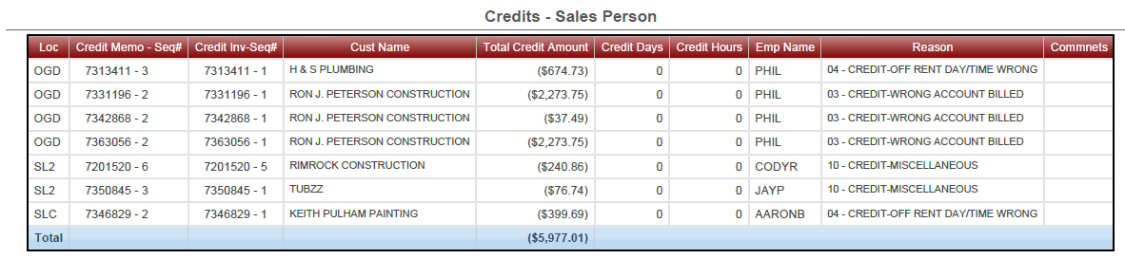



* **This Boom Lift has been off rent for 9 days and not picked up yet.**
* **The rental stops when it is called off rent, but the time utilization does not so this will distort the ROI on this equipment.**

**Type of rollover**

* **Pick up**
* **Exchange**
* **Service Call**
* **Inter-company**
* **Move**

20

* View what we are rolling over and why? Service calls and exchange rollovers should be looked into.

### Pick-up Rollover Report

**Review equipment and reasons to determine if we could have substituted with another piece of equipment or if a small piece of equipment, could we have bought it?**

**Depending on the customer and job, did we entertain re-renting for the customer?**

* **Although this was a rate inquiry from a customer who was putting a bid together, did we set a follow up date to call the customer back? Or turn over to an outside sales person.**

21

**Review names to identify any new, high volume or loyal customers to ensure follow up took place with outside sales**

* Identify possible inventory deficiencies with consistent lost rentals on specific pieces of equipment or “Equipment Substitution” was listed as reason for lost rental.
* Follow up with counter & outside sales to determine if all possible questions were asked and all options were exhausted to secure the rental.
  + Did the counter immediately follow up with outside sales person if the rental was lost to price?
  + Use as an education tool to train
* Identify possible operational deficiencies if the reasons are due to “Delivery Time Problem” or “Equipment was in the shop”

### Lost Rental Log - Daily

* Helps you monitor what is going on with auction items. They may be set for auction 2 or 3 months out so you can continue to rent until replacement shows up.

**Let’s you know what is still out on rent and may need to be exchanged to take to auction**

**Items set for auction. Fleet should have Cap-x units on the way**

### Equipment for Auction

22

**These numbers indicate how many of pieces of equipment this Metro Market region carries by branch and the current status**.

**This box indicates what status the equipment is currently in.**

**Out = On rent**

**In = In the yard**

**Shp – Inside shop (broken and waiting for parts)**

* Keeping up with an balanced inventory within your Metro Market will help take care of your customers better and increase dispatch efficiency with deliveries.

**Equipment Inventory Balance Report**

23

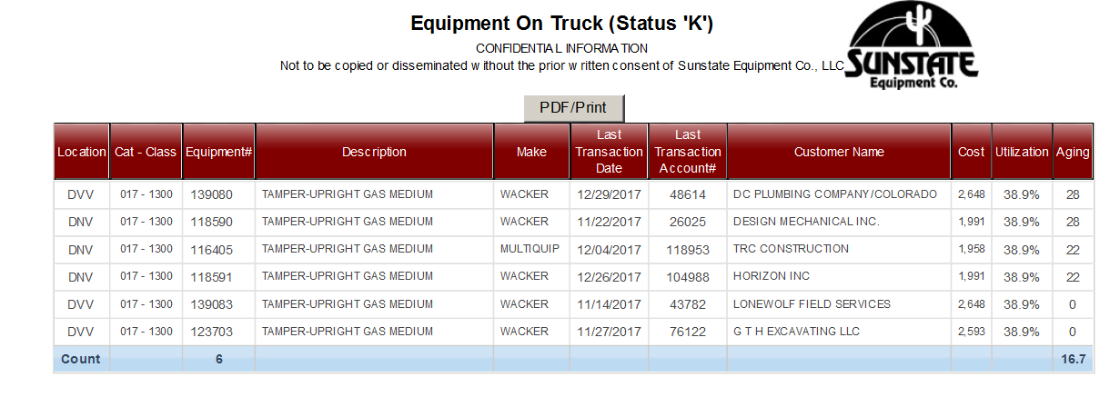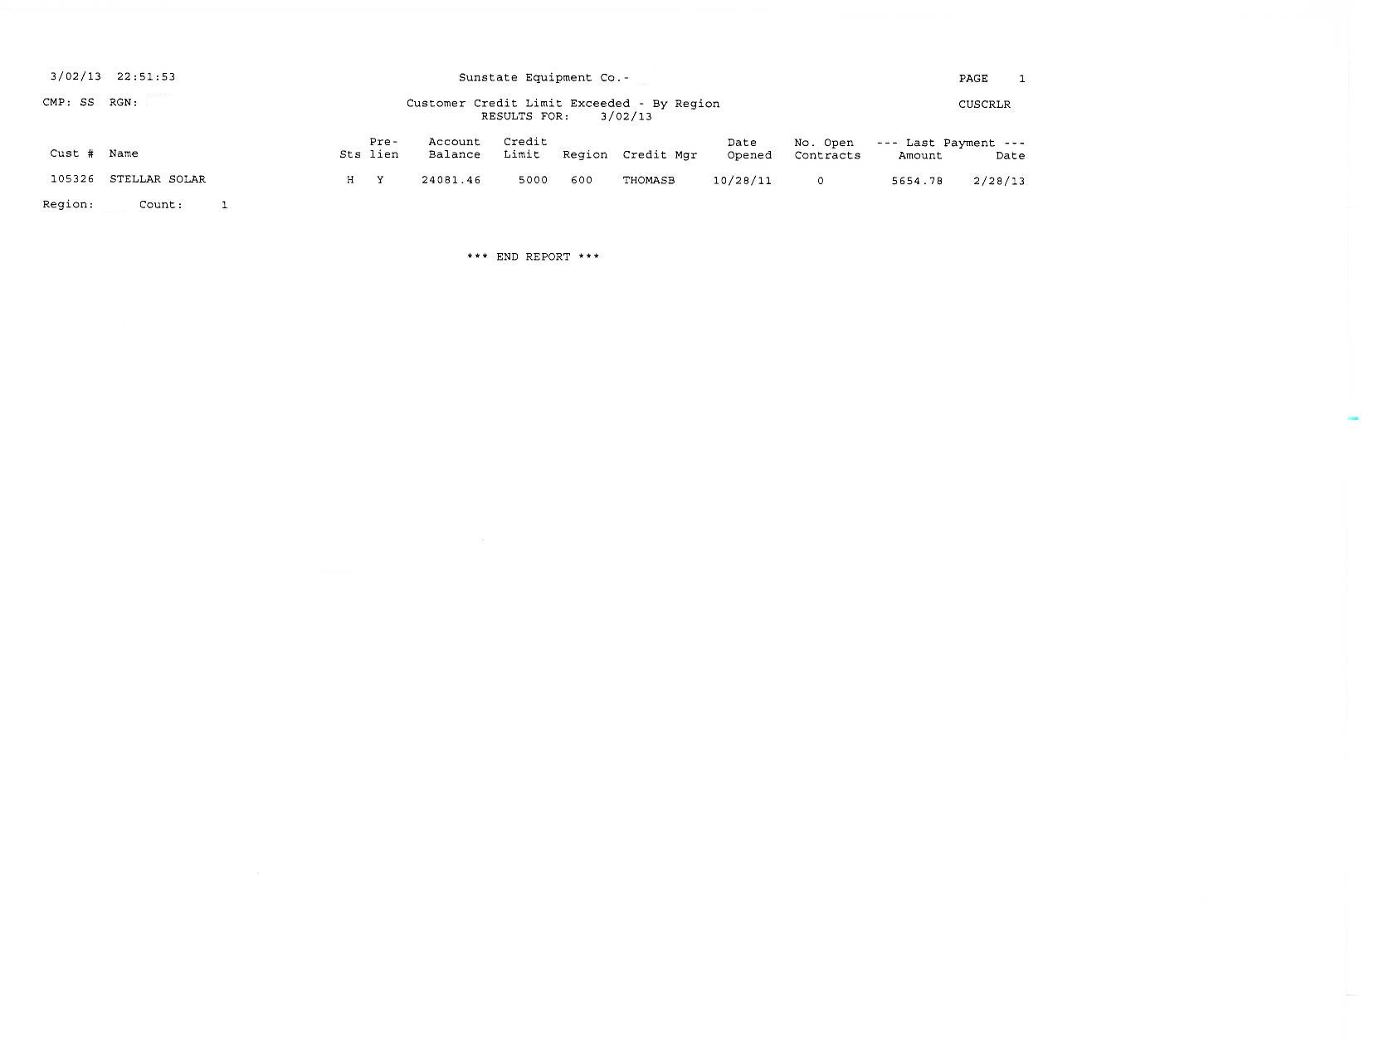

**MANAGEMENT REPORTS GUIDE**

Weekly Reports

24

**Guidance-Throughout:**

* Identify customer accounts that have been placed on “Temporary Inactive Status”
  + Accounts that have a whole balance of $750.00 or less
  + 90 or more days past due
* If the entire account balance is paid within 6 months of when the account was placed “Temporary Inactive”, the account will be re-activated.
* Share with outside sales to alert them of any large, steady accounts that may be listed
  + Serves as a flag so sales / operations can possibly assist in collection if a relationship has been established.

**Note:** This report prints off on the 15th of every month. It is not included with the monthly management reports.

## Small Balance Temporary Inactive Report

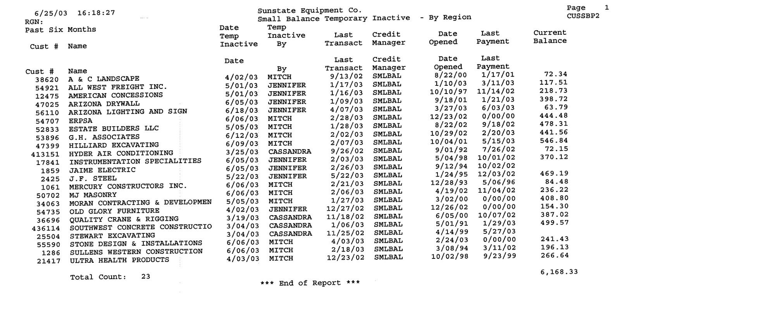

* Verify equipment that is currently stocked on one-ton delivery trucks.
* It can also identify if there are any trucks that are not properly stocked or not documented as being stocked.
* Equipment stocked on the trucks need to be rotated with newly serviced equipment every two weeks to ensure the equipment is always in good working condition.

## Equipment On Truck – Status “K”

**The aging is used to see how long it has been on the truck, here it shows 1 for 28 days and the other for 22 days. They should be replaced every 2 weeks.**

**Did the driver verify if this unit was in good working condition when it was loaded?**

**It is important that the truck number is entered into AS400 on the comments line when the status is changed to On Truck so that it can be easily tracked.**

**Shows what branch it came out of, unit number and type of equipment**

25

26

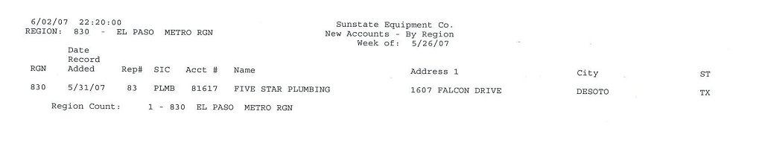

## New Accounts

* Lets you view what new accounts were opened the past week.
* Share with your sales team.

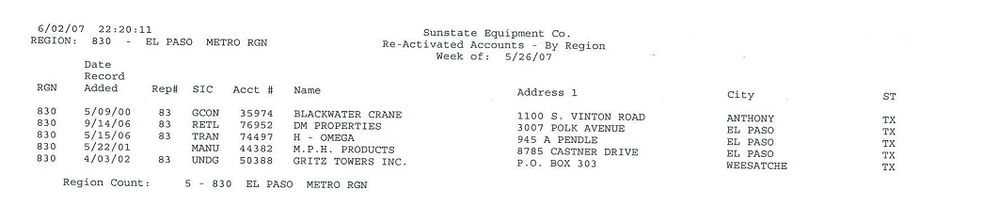

## Reactivated Accounts

* Lets you view accounts re-activated during the week.
* Accounts will go in-active after no use in 24 months.
* Share with your sales team.

27

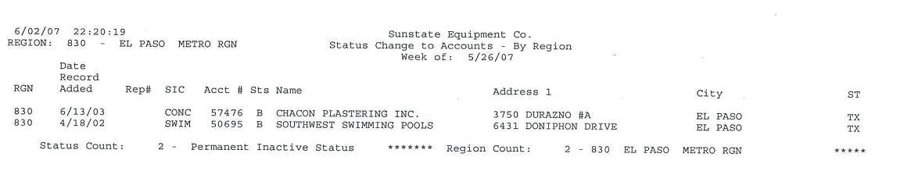

## Status Change to Accounts

* Help the Credit Department if you know something about the job or company.

**Status Codes**

**Status Codes:**

A = Active Account

I = Inactive Account

H = Customer on hold due to owing money

B = Closed account due to bad address/no phone number or company name change

S = Suspended Account – in legal action with collections

T = Temporarily Inactive – balance due (under $750)

28

**This is telling us that the credit department has updated their (Status) to “On Hold” and is addressing any issues with the account.**

**This just gives you awareness that a customer is exceeding their credit limits.**

## Customer Credit Limit Exceeded

29

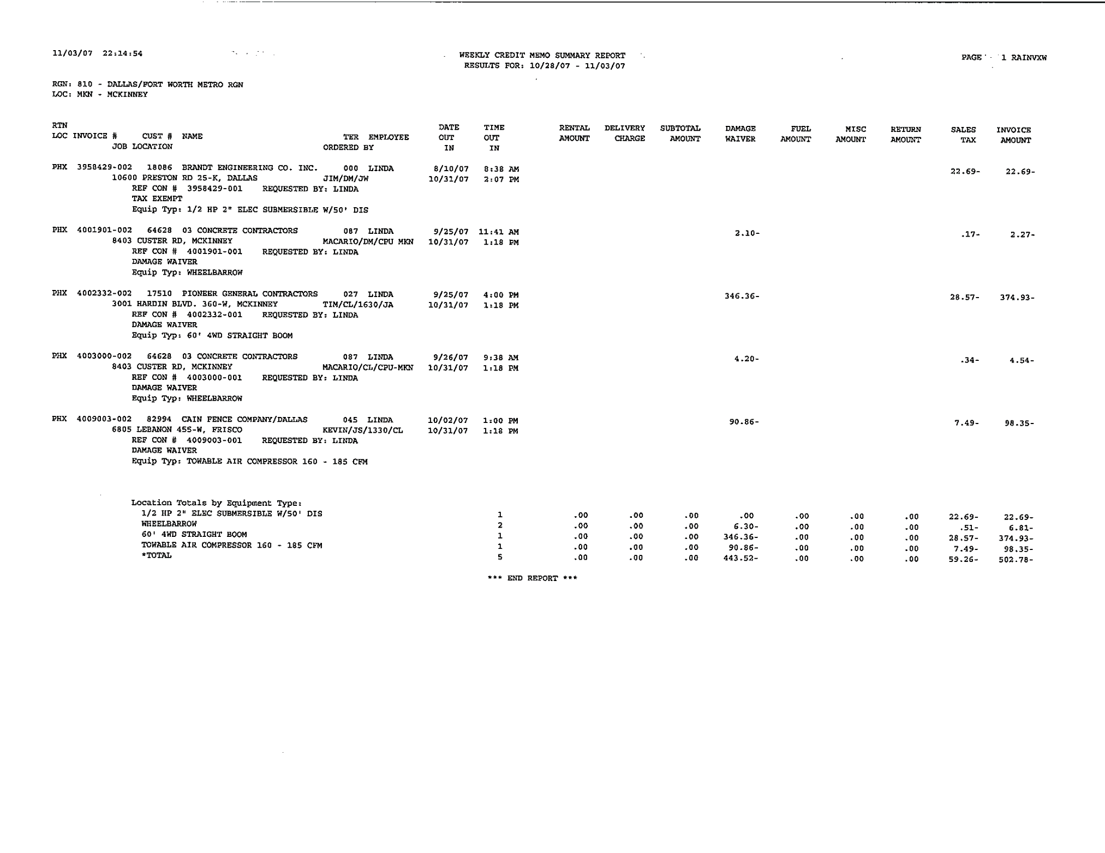

## Weekly Credit Memo Summary Report

## Weekly Credit Memo Summary Report

* This report is used in a similar manner to the Daily credit memo summary report on page 23.
* As a branch manager you should review this report to verify that you have the awareness of all credits that were issued.
* Review each line item to identify multiple credits for the same reason. (This could be used as a great teaching tool on the counter)



30

* Identifies customer service issues that could damage a relationship.
  + Downtime for customers
  + Credit hours / days
  + Communicate to outside sales
* Compare “last maintenance meter” to “current meter” to determine if an exchange was more appropriate because the unit may be approaching or due for a full service.

**The “last location” column represents the location where the contract was generated**

**This is important in Metro Markets.**

**This is all driven off the service call report and the time it took a mechanic to complete the call**

## Equipment Service Call – Code 150

* Identify ISR/ Dispatch’s service call vs. exchange judgment.
  + Most efficient solution
* Look for same day calls. What was the problem? Was it a preventable maintenance issue we missed?
* Determine if it is customer damage, if so notify customer ASAP.
* Did the Customer run unit out of fuel? – Did we charge service call fee and fuel for this call out?
* Do we have calls on same equipment during the week?

31

32

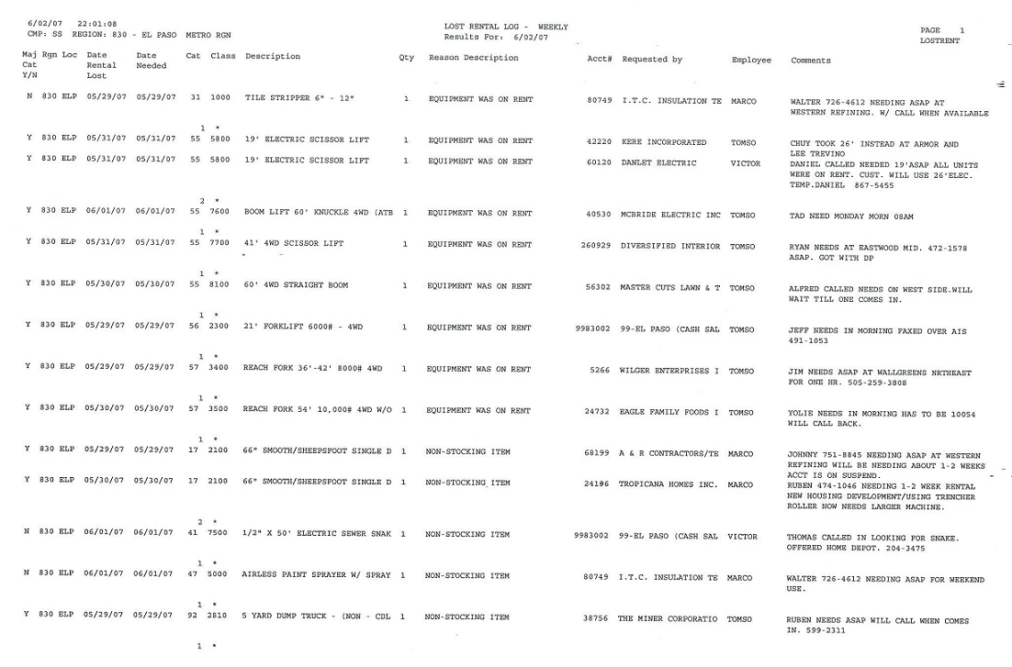

## Lost Rental Log - Weekly

* Watch for equipment trends (missing rentals).
* Was the 3 minute egg timer used? Are the inside sales people consistent with putting these in?

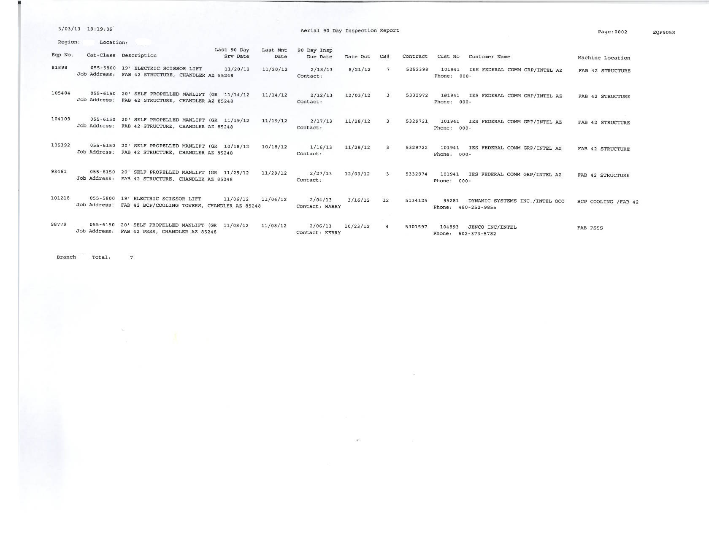

**The Last 90 Day Service Date**

**90 Day Inspection Due Date**

**You can see this Scissor lift went out back on 8-21-12 and it had a 90 Day inspection on 11-20-12**

**The unit is still on rent and is now due again for its 90 day inspection.**

**All Aerial products must be serviced every 90 days when it is in the field.**

**This report will help you manage your inspections**

33

Aerial 90 Day Inspection Report

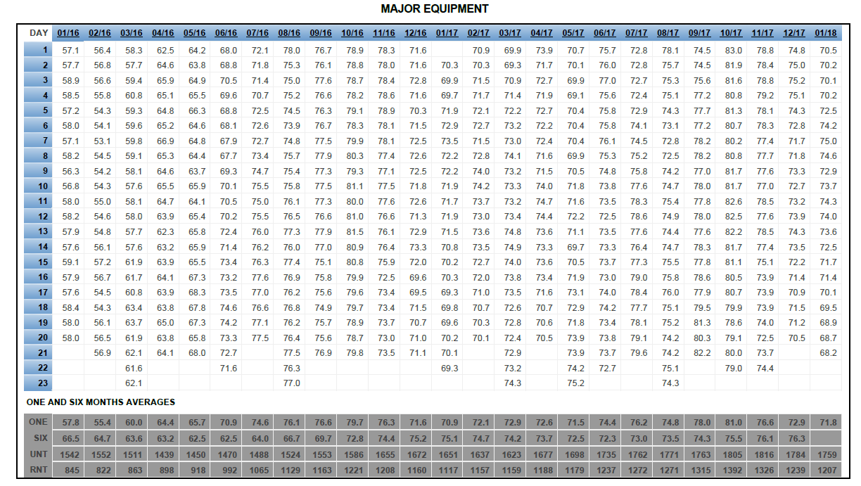

**MANAGEMENT REPORTS GUIDE**

Monthly Reports

**Billing Days of the month in order 1 to 31**

**Guidance -Throughout:**

* Determine the % of the fleet that was on rent for each billable day.
  + Majors goal = 65% - 75% (equipment cost over $5000)
  + Minors goal = 25% - 30% (equipment cost under $5000)
  + Each days utilization percentages are calculated during nightly reporting. Any equipment that shows “on rent” or “scheduled for pick up” will be calculated into the utilization percentage. All returns and rental outs must be processed by the end of the day in order to achieve an accurate percentage.
  + If a rental contract is opened and closed during the same day before the nightly reporting, the piece of equipment will not be reported as being on rent for the day.
* The bottom of each half of the report lists:
  + One month’s utilization average (ONE)
  + Six month’s utilization average (SIX)
  + Number of units in the fleet for the month (UNT)
  + The total number of units on rent (RNT)
* Review trends compared through the past 25 months.
  + General overview of fleet activity
* Use monthly average as a bench mark, compare it against last years monthly average and the previous month
  + When comparing utilization, pay attention to the number of units in your fleet to help understand trends.

(I.e. Is utilization up due to an increase of business, or a decrease in the size of fleet?)

## Equipment Utilization Report

34

**One Month & Six Month Averages**

**Billing Days of the month in order 1 to 31**

35

* Identify trends in the number of contracts written for each billable day of the month.
  + One and six month averages are listed at the bottom of report
* Measure the level of activity.
  + Is the daily business growing or fading?
  + Compare to previous month and season to determine what action needs to take place to meet current and future business levels

(I.e. hiring, adding delivery / rental fleet, etc.)

* Another tool to aid in determining staffing needs to meet the level of business.
  + Opportunity to identify if the team is working efficiently with current business level

## Contract Trends Report

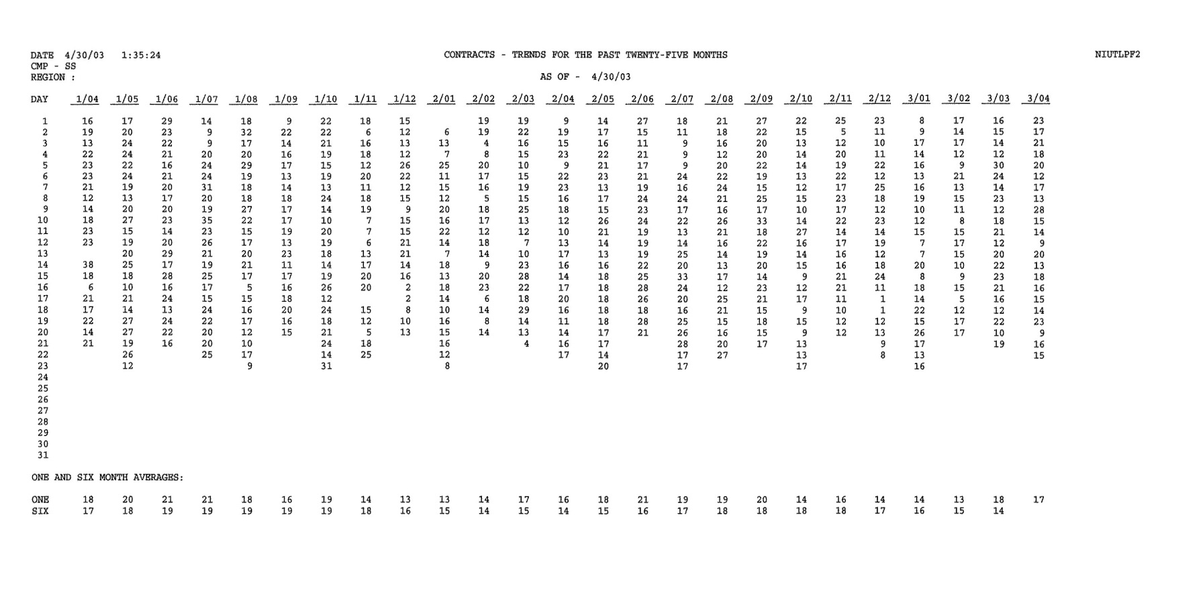

**Looks like we added 7 units this year and Utilization is still above target, the ROI will need to trend back up but this is just a two month snap shot.**

**Total # of units as a company with Utilization and ROI trends from previous year.**

**Company targets for Utilization and ROI each cat class of equipment.**

* Determine the performance of each cat/class of equipment in the fleet.
  + Identify good or under performing equipment
  + Compare the branch’s performance to the company’s (consolidated) performance
* Use the Equipment Utilization Trends Report and Equipment Revenue Report in conjunction to this report to gain detail on each category class.
  + If a cat/class is under performing, the Equipment Revenue and Utilization Reports can reveal specific equipment numbers that are not being rented which lowers the average of the entire cat/class – then determine why

## Regional Analysis Report (RP Report)

36

**What the company target ROI is for that cat class.**

**Asterisk = Unit not meeting target ROI**

37

* Review rental revenue for each piece of numbered equipment.
  + Compare against the target
* The revenue, maintenance costs and R.O.I. % are grouped into three periods
  + - Previous month
    - Year to date
    - Life to date
  + Asterisks (*) next to the equipment number indicate that particular piece of equipment is not meeting the targeted R.O.I. % on an annualized basis.
  + A date in the “date sold” column indicates it is no longer in the fleet.

(I.e. Was the unit replaced? If not, does it need to be replaced based off of the utilization and R.O.I.?)

* Identify under performing fleet.
  + Sales / marketing issues
  + Surplus equipment
  + Possible configuration issues
  + Discounted rates
  + Identifies equipment rotation issues

(I.e. 4 out of 5 machines have all of the revenue and 1never gets rented)

* Acknowledge what specific equipment is doing well.
  + Determine if additional units are needed
* Identify maintenance expenses on specific pieces of equipment.
* **RETAIN THE YEAR END EQUIPMENT REVENUE REPORT** for reference during the first couple of months of the New Year until new trends are calculated and for up to two years for historical trends.

## Equipment Revenue Report

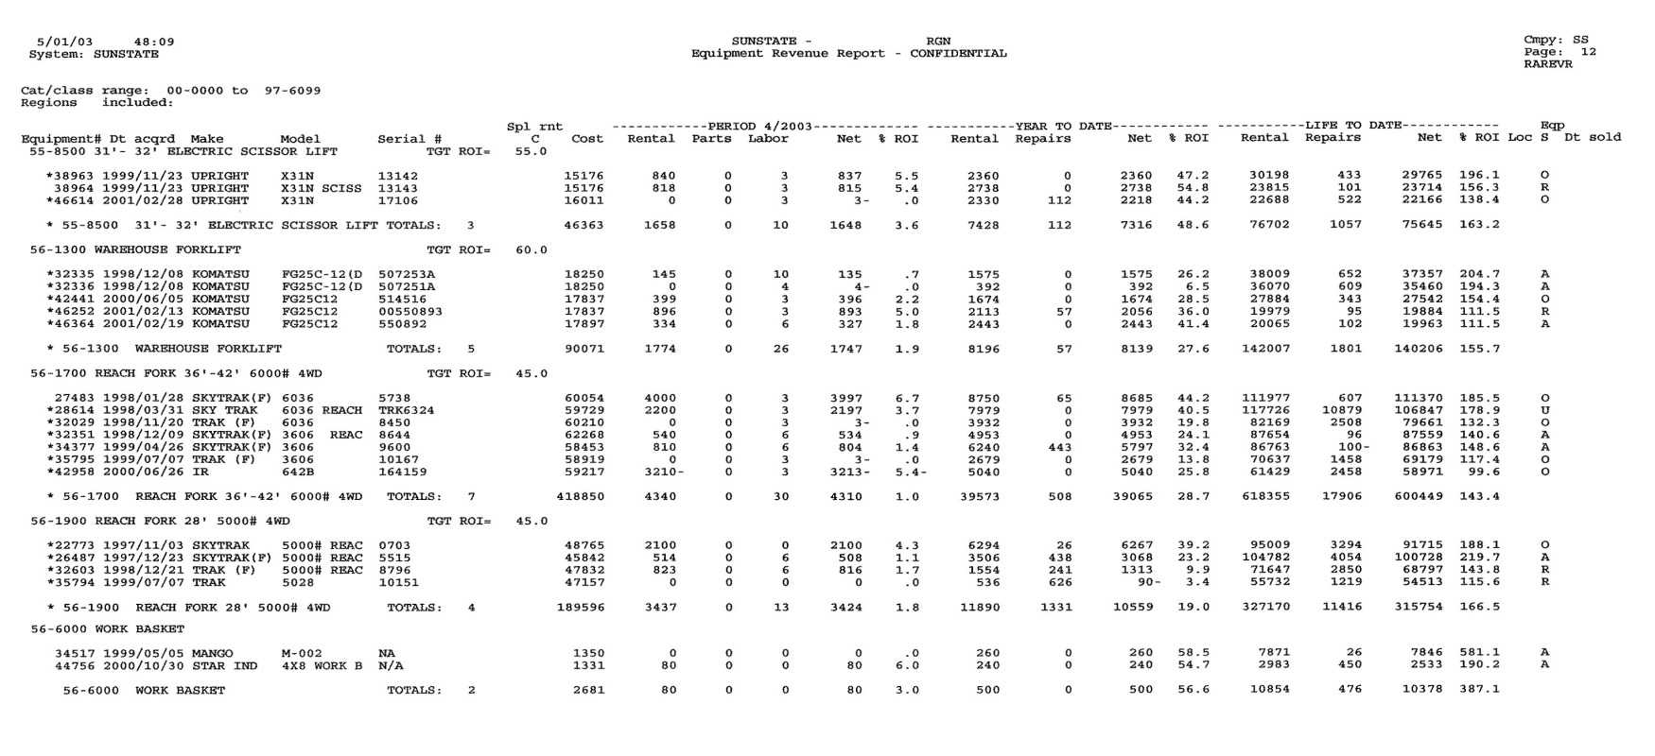

38

* Use as a resource to identify current and previous trends in equipment utilization for specific classes of equipment for a running 12 months.
* It lists the average number of pieces of equipment in the fleet for each month under “owned”
* Fractions of whole numbers are due to the fluctuation of the numbers of equipment that were transferred in or out during the month
* It lists the average number of pieces of equipment on rent for the month under “out”
* It lists the number of billable days in each reported month
* Compare against targets
* Compare the current utilization to previous month or season.
* If trends are either up or down, investigate the following to understand why:
* Customer base – is it growing or deteriorating for users of that equipment? Is it one large user, or many users? And are they heavily discounted customers?
* Sales – work with sales team to understand upcoming jobs and/or customers that will be using the equipment
* Review Equipment Revenue Report to understand R.O.I. vs. Utilization
* Performance of similar machines

(I.e. 5000# reachout forks vs. 6000# reachout forks)

## Equipment Utilization History – by month

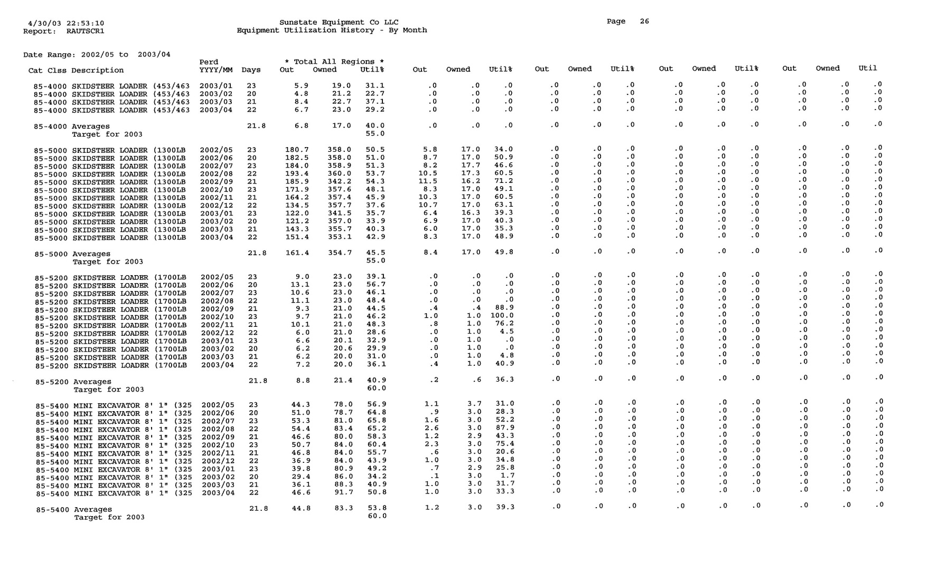

39

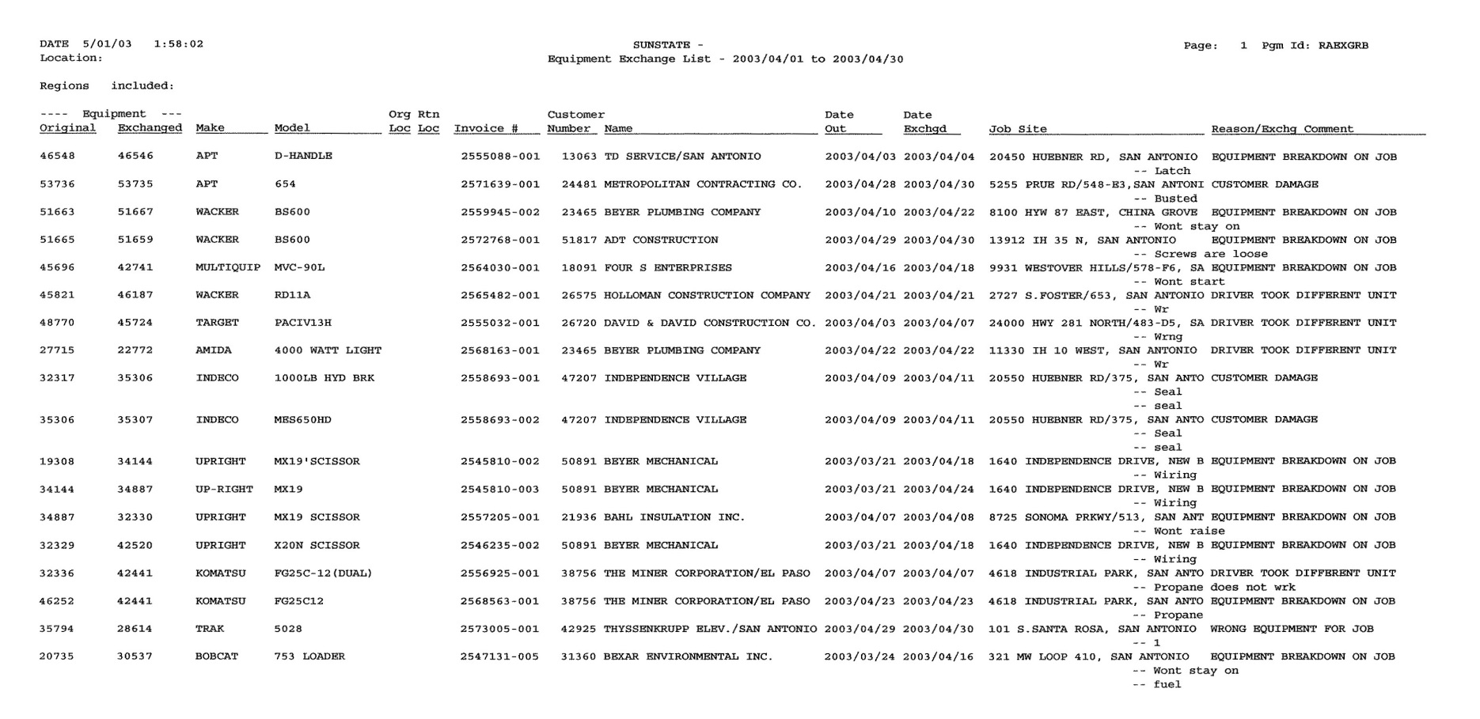

## Equipment Exchange List

* Identify possible breakdown trends when there are repeated:
  + Preventative maintenance issues
    - Consistent specific breakdowns

(I.e. Pull ropes continually breaking on many units)

* + - Possible training issue in shop

(I.e. Checking wear surfaces)

* + Consistent mechanical issues with a specific pieces

(I.e. Has the problem been fixed?)

* + Specific customer (misuse, wrong application)

(I.e. CUSTOMER DAMAGE)

* Review with shop personnel regularly.
* Review reasons to determine:
  + Inefficiencies with pre-orders and staging, etc.

(I.e. DRIVER TOOK DIFFERENT UNIT)

* + Counter & Sales determining the right equipment for job

(I.e. WRONG EQUIPMENT FOR JOB)

* + Possible customer service issues that could potentially damage a relationship

(I.e. Multiple breakdowns)

* Review overall mechanical issues & repairs to determine:
  + Preventative maintenance issues
    - Consistent specific breakdowns
    - Possible training issue in shop
    - Review “rental out date”
  + Consistent mechanical issues with a specific number
  + Discuss and review in shop meeting
  + Customer misuse or wrong application
    - Follow up by educating the customer
* Identifies customer service issues that could damage a relationship.
  + Downtime for customers
  + Credit hours / days
  + Communicate to outside sales
* Compare “last maintenance meter” to “current meter” to determine if an exchange was more appropriate because the unit may be approaching or due for a full service.

## Equipment Service Call Report

40

41

* Identify any equipment that has not rented for at least 60 days.
  + Review last transaction date
  + Review number of months inactive
* Determine if the equipment is being rotated.
  + Mechanic / yard person could always be putting the same, newly serviced units at the front of the line after service
  + A piece of equipment in the back of the line that is picked over due to cosmetics, etc.
* Use to help with developing a marketing / sales strategy for under performing fleet to target specific SIC codes who normally rent the listed equipment.
  + Share during sales meetings
* Identify if there are potential deficiencies in having enough appropriate accessory items for the type of equipment.
  + Hoses, bits, blades, etc.
  + Attachments
* Identify surplus equipment.
  + Understand what the seasonal items are before placing them on the surplus list
* Equipment that has not been active may need to be check serviced again to ensure that batteries, etc. are good and the unit is rental ready.

## No Activity Report

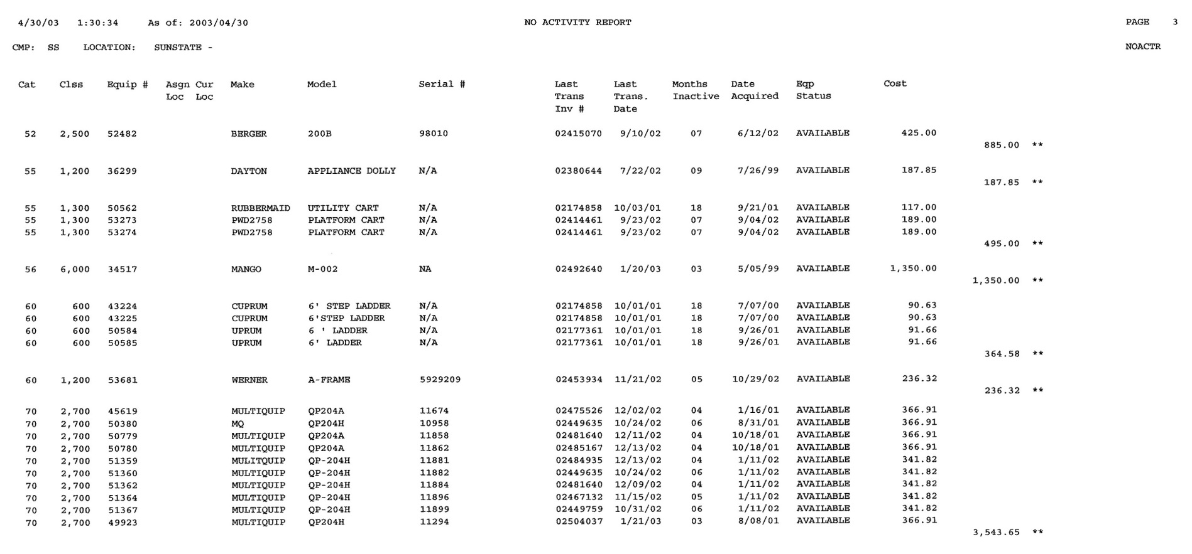

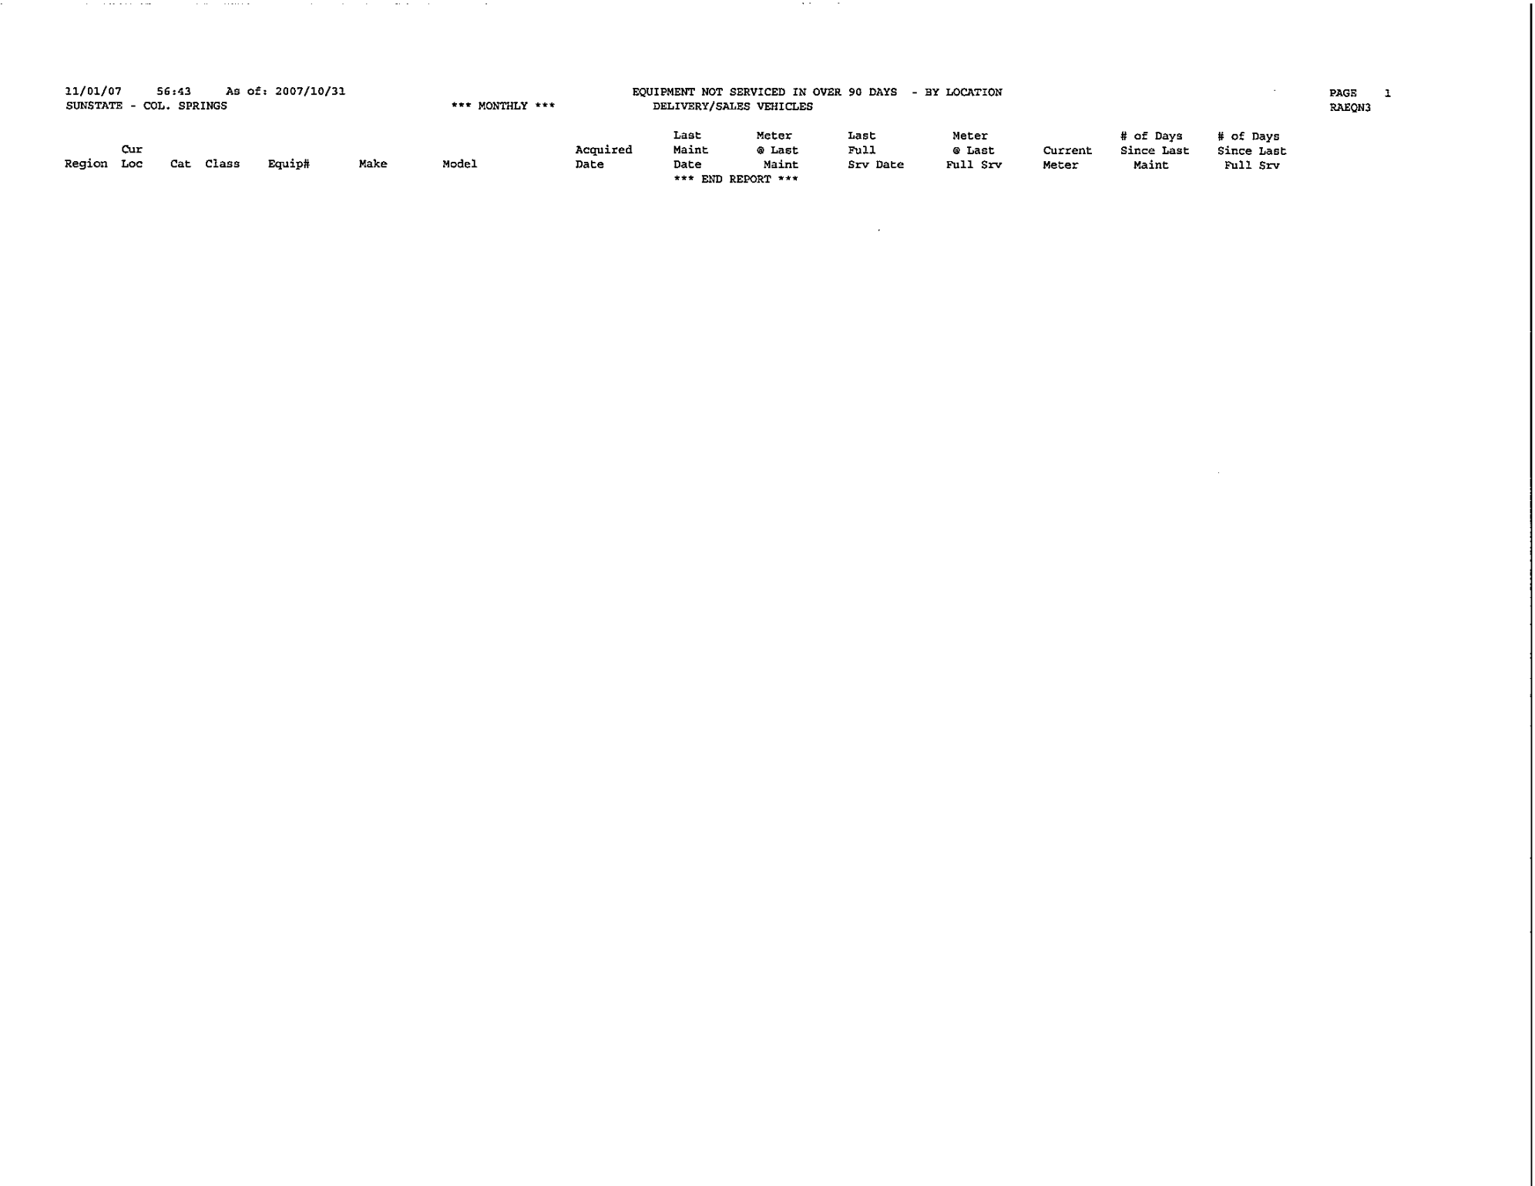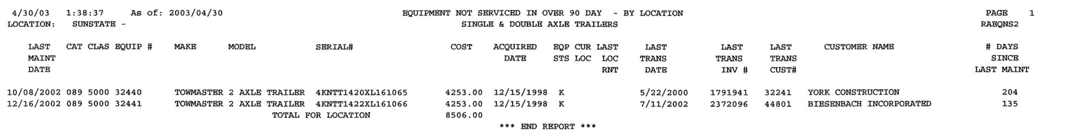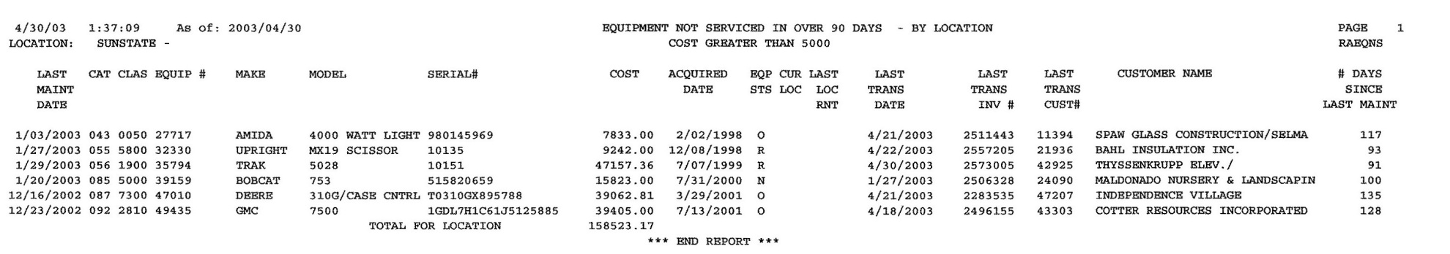

42

* When a piece of equipment’s repair expenses reaches and exceeds 10% of the revenue generated, this report is generated.
  + Review the life to date calculations
  + Review the year to date calculations
* Investigate any excessive repair expenses.
  + Understand what repairs were performed
  + Research maintenance history in the AS400
* Can help identify errors when parts are expensed to the wrong piece of equipment.

(I.e. A drill with a cost of $45 LTD repairs are $1000.00, a costly part was likely expensed to the wrong equipment number)

* Determine if it is cost effective to continue to invest money into a specific piece of equipment that will continue to require consistent costly repairs in the future.
  + Review “acquired date”
  + Use in conjunction to the Equipment Revenue Report to determine the R.O.I.
  + Small equipment – Repair vs. Replace

## Repairs as a Percentage of Revenue

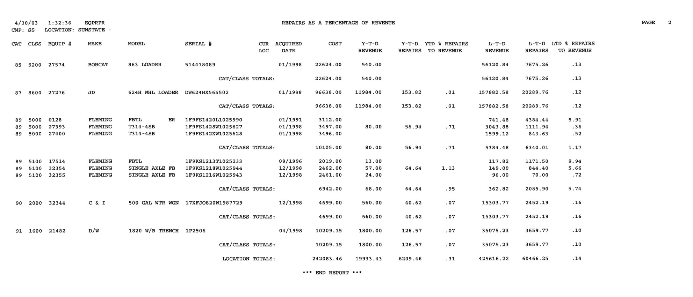

* Identify rental equipment, trailers & delivery fleet that have not been serviced in at least 90 days.
  + The last maintenance date is listed in the far left side
  + The number of days since last maintenance date is located on the far right side
  + Rental fleet listed has a cost of $5000 or greater
* Identify if equipment that shows available is being rotated.
  + Print out SMF’s for each available unit and ensure a check serviced is performed
* Monitor if the trailers are regularly being serviced and service history inputted into the AS400.
* Identify if equipment out on long term rentals are being serviced regularly.
  + If the daily “Equipment Cycle Billed – Due for Service” Report is consistently monitored and services are regularly performed, then equipment will not be reported here
  + Our preference is to exchange the unit when it due for service. However we will do a service call if it is more convenient for the customer
  + Aerial equipment must have 90 day inspections performed

(**Please Note:** The 90 day service is from the last service date, not the start rental date.)

* + Towable generators must be checked monthly for excessive use (Overtime)
* Verify if sales & delivery vehicles are regularly being serviced and service history inputted into the AS400.
* An SMF should be printed and filled out whenever a vehicle is taken to an outside shop for service (Jiffy Lube)

## Equipment Not Serviced in 90 Days

43

* Understand the dollar volume generated by each SIC code.
* Use to help with developing a marketing / sales strategy to target specific SIC codes that are under performing.
  + Share during sales meetings
  + Do we have the right fleet available?
  + Are we targeting specific types of customers to improve the diversity of our customer base, and ultimately the diversity of our fleet?
* Compare previous months’ Sales Summary to identify sales trends.
  + Investigate why a particular SIC code volume has fluctuated up or down
    - Particular job completed or started

## Sales Summary by SIC Code – by volume

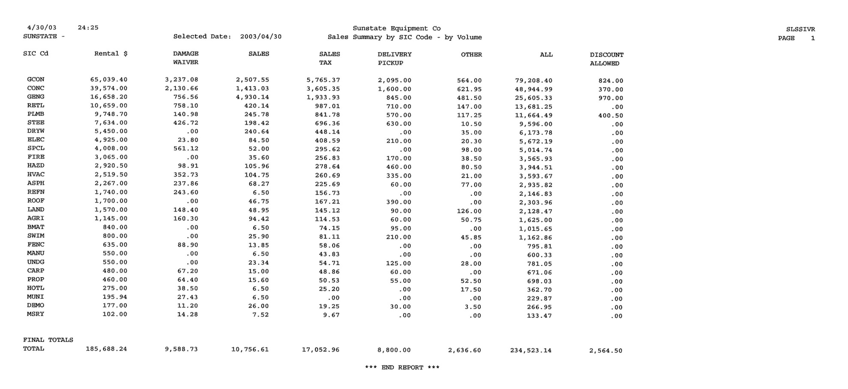

44

45

* Identify trends with specific customers.
  + It lists the previous month, the current year, last years dollar volume and life to date revenues
* Understand why their volume is changing – up or down.
  + Do we have relationships with each customer?
  + Do we realize the full potential of their business?
* Review and discuss in sales meetings.
* To obtain additional specific sales history for a customer, refer to the Customer Trend Analysis Report.

## Sales by Customer Report

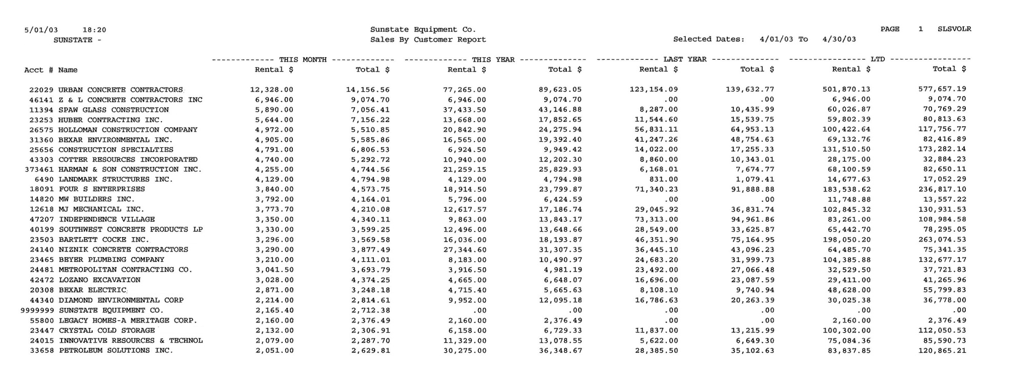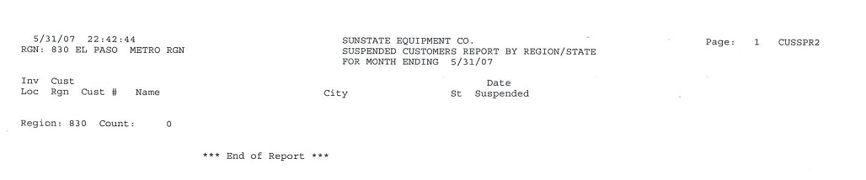

## Suspended Customers

46

47

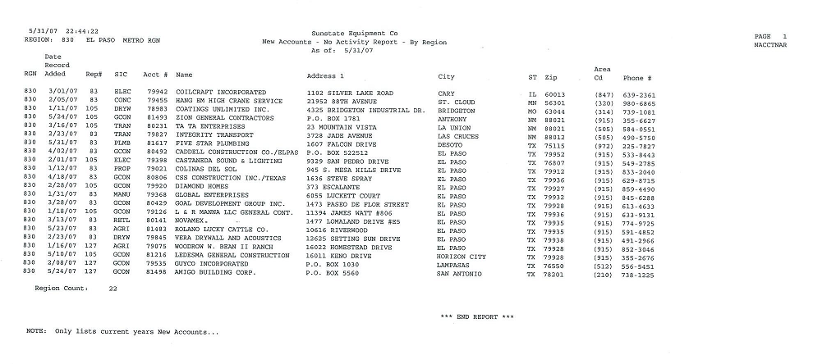

## New Accounts – No Activity Report

* Great info to use in a Sales Meeting. These accounts were opened for a reason, so why haven’t they rented yet?
* Use to make cold calls with Sales people.

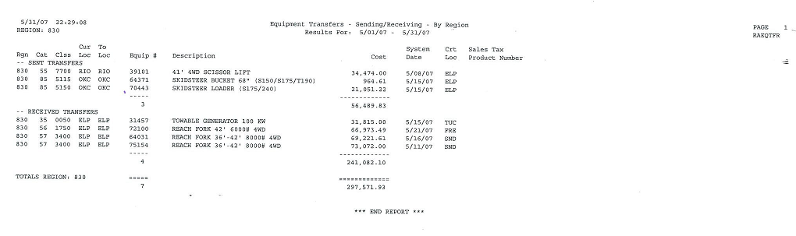

## Equipment Transfers – Sending/Receiving

* Keeps track of what you have sent out during the month and received.

48